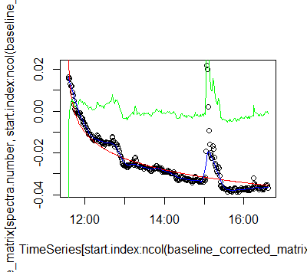Figure 1: UV-Vis Absorbance Signal Uncorrected (black) and Corrected (green) for Lamp Drift

Figure 2: Schematic of Double Beam UV-Vis Setup

Sample Detector

Waveguide

To Computer

Beam Splitter

Source Lamp

Attenuator

Reference Detector

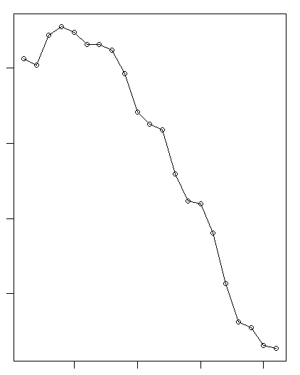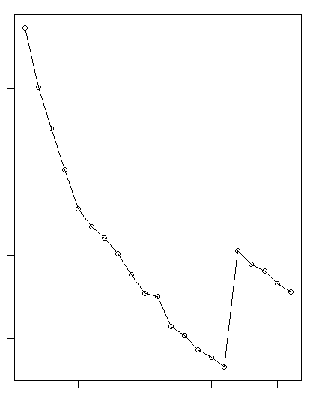Figure 3: Reference (left) and Sample (right) Absorbance Time Series

Absorbance

Absorbance

Index

Index